Week 2- PL SQL Programming- Hands-On Exercises

Exercise 1: Control Structures

Scenario 1: The bank wants to apply a discount to loan interest rates for customers above 60 years old.

Query:

DECLARE
TYPE customer_record IS RECORD (
customer_id NUMBER,
name VARCHAR2(100),
age NUMBER,
loan_interest_rate NUMBER
);

TYPE customer_table IS TABLE OF customer_record;

customers customer_table;

new_customer_id NUMBER;
new_name VARCHAR2(100);
new_age NUMBER;
new_loan_interest_rate NUMBER;
BEGIN
customers := customer_table(
customer_record(1, 'Hema Srivalli', 65, 5.00),
customer_record(2, 'Pratyusha', 58, 4.50),
customer_record(3, 'Jyothsna', 72, 6.00),
customer_record(4, 'Siddhi', 45, 3.75),
customer_record(5, 'Dolly', 62, 5.25)
);

FOR i IN 1 .. customers.COUNT LOOP
new_customer_id := customers(i).customer_id;
new_name := customers(i).name;
new_age := customers(i).age;
new_loan_interest_rate := customers(i).loan_interest_rate;

IF new_age > 60 THEN
new_loan_interest_rate := new_loan_interest_rate * 0.99;

DBMS_OUTPUT.PUT_LINE('Updated customer ID: ' || new_customer_id ||
', Name: ' || new_name ||
', Age: ' || new_age ||
' - New interest rate: ' || new_loan_interest_rate);
END IF;
END LOOP;

EXCEPTION
WHEN OTHERS THEN
DBMS_OUTPUT.PUT_LINE('An error occurred: ' || SQLERRM);
END;
/

Output:
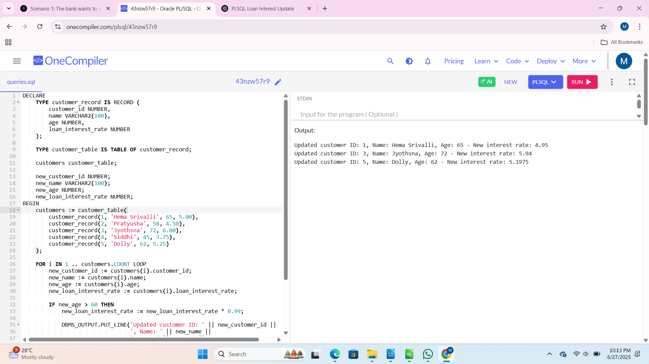
Scenario 2: A customer can be promoted to VIP status based on their balance.
Question: Write a PL/SQL block that iterates through all customers and sets a flag IsVIP to TRUE for those with a balance over $10,000.

Query:

DECLARE
TYPE customer_type IS RECORD (
customer_id NUMBER,
name VARCHAR2(100),
balance NUMBER,
is_vip BOOLEAN
);

TYPE customer_table IS TABLE OF customer_type;

customers customer_table := customer_table(
customer_type(1, 'Siddhi', 7500, FALSE),
customer_type(2, 'Pavan', 12000, FALSE),
customer_type(3, 'Pratyusha', 9000, FALSE),
customer_type(4, 'Jyothsna', 25000, FALSE),
customer_type(5, 'Dolly', 8000, FALSE)
);

vip_threshold CONSTANT NUMBER := 10000;

BEGIN
DBMS_OUTPUT.PUT_LINE('VIP Promotion Processing');
DBMS_OUTPUT.PUT_LINE('------------------------');

FOR i IN 1..customers.COUNT LOOP
IF customers(i).balance > vip_threshold THEN
customers(i).is_vip := TRUE;
DBMS_OUTPUT.PUT_LINE('Promoted to VIP: ' || customers(i).name ||
' (Balance: $' || customers(i).balance || ')');
ELSE
DBMS_OUTPUT.PUT_LINE('Not qualified: ' || customers(i).name ||
' (Balance: $' || customers(i).balance || ')');
END IF;
END LOOP;

DBMS_OUTPUT.PUT_LINE(CHR(10) || 'Final VIP Status:');
DBMS_OUTPUT.PUT_LINE('-----------------');

FOR i IN 1..customers.COUNT LOOP
DBMS_OUTPUT.PUT_LINE(
RPAD(customers(i).name, 15) || ' | ' ||
RPAD('$' || customers(i).balance, 10) || ' | ' ||
CASE WHEN customers(i).is_vip THEN 'VIP' ELSE 'Regular' END
);
END LOOP;
EXCEPTION
WHEN OTHERS THEN
DBMS_OUTPUT.PUT_LINE('Error: ' || SQLERRM);
END;
/

Output:

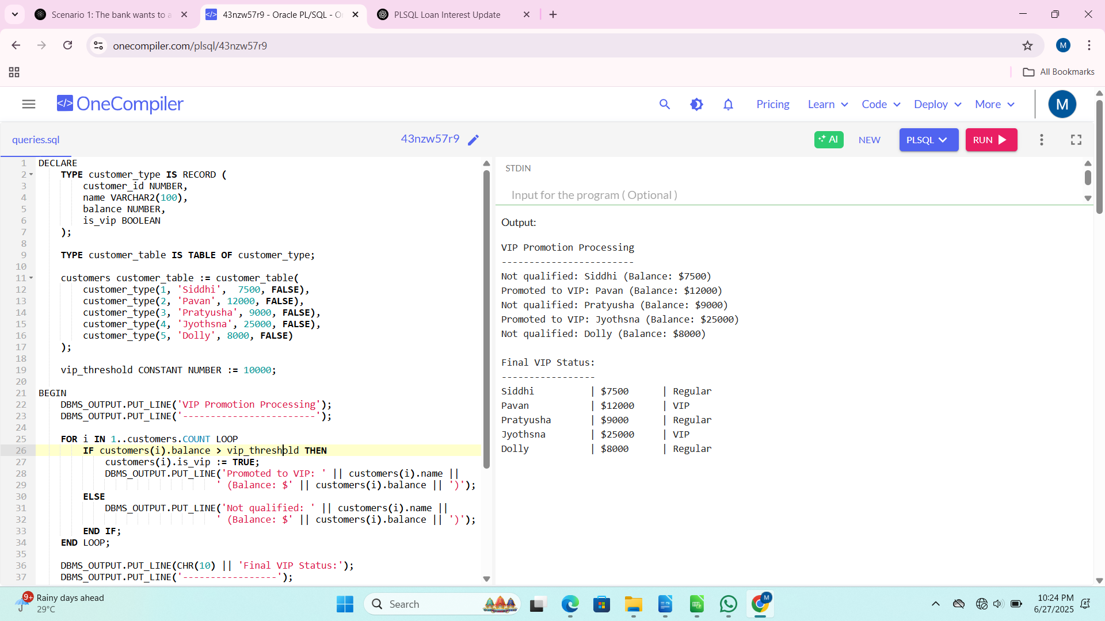
Scenario 3: The bank wants to send reminders to customers whose loans are due within the next 30 days.

Query:

DECLARE
TYPE loan_type IS RECORD (
loan_id NUMBER,
customer_name VARCHAR2(100),
due_date DATE,
amount NUMBER,
is_reminder_sent BOOLEAN
);

TYPE loan_table IS TABLE OF loan_type;

loans loan_table := loan_table(
loan_type(101, 'Anuhya', SYSDATE + 15, 5000, FALSE),
loan_type(102, 'Anitha', SYSDATE + 60, 7500, FALSE),
loan_type(103, 'Usha', SYSDATE + 5, 12000, FALSE),
loan_type(104, 'Akshitha', SYSDATE + 28, 8000, FALSE),
loan_type(105, 'Satyavathi', SYSDATE + 31, 3000, FALSE)
);

c_reminder_days CONSTANT NUMBER := 30;

BEGIN
DBMS_OUTPUT.PUT_LINE('LOAN REMINDER PROCESSING');
DBMS_OUTPUT.PUT_LINE('------------------------');

FOR i IN 1..loans.COUNT LOOP
IF loans(i).due_date <= SYSDATE + c_reminder_days THEN
loans(i).is_reminder_sent := TRUE;

DBMS_OUTPUT.PUT_LINE('REMINDER: ' || loans(i).customer_name ||
CHR(10) || 'Loan ID: ' || loans(i).loan_id ||
CHR(10) || 'Amount Due: $' || loans(i).amount ||
CHR(10) || 'Due Date: ' || TO_CHAR(loans(i).due_date, 'DD-MON-YYYY') ||
CHR(10) || 'Days Remaining: ' || (loans(i).due_date - SYSDATE) ||
CHR(10) || '-----------------------------------');
END IF;
END LOOP;

DBMS_OUTPUT.PUT_LINE(CHR(10) || 'REMINDER SUMMARY');
DBMS_OUTPUT.PUT_LINE('----------------');

FOR i IN 1..loans.COUNT LOOP
DBMS_OUTPUT.PUT_LINE(
RPAD(loans(i).customer_name, 20) || ' | ' ||
RPAD('#' || loans(i).loan_id, 10) || ' | ' ||
RPAD(TO_CHAR(loans(i).due_date, 'DD-MON'), 10) || ' | ' ||
CASE WHEN loans(i).is_reminder_sent THEN 'REMINDER SENT' ELSE 'Not due soon' END
);
END LOOP;

EXCEPTION
WHEN OTHERS THEN
DBMS_OUTPUT.PUT_LINE('Error processing reminders: ' || SQLERRM);
END;
/

Output:

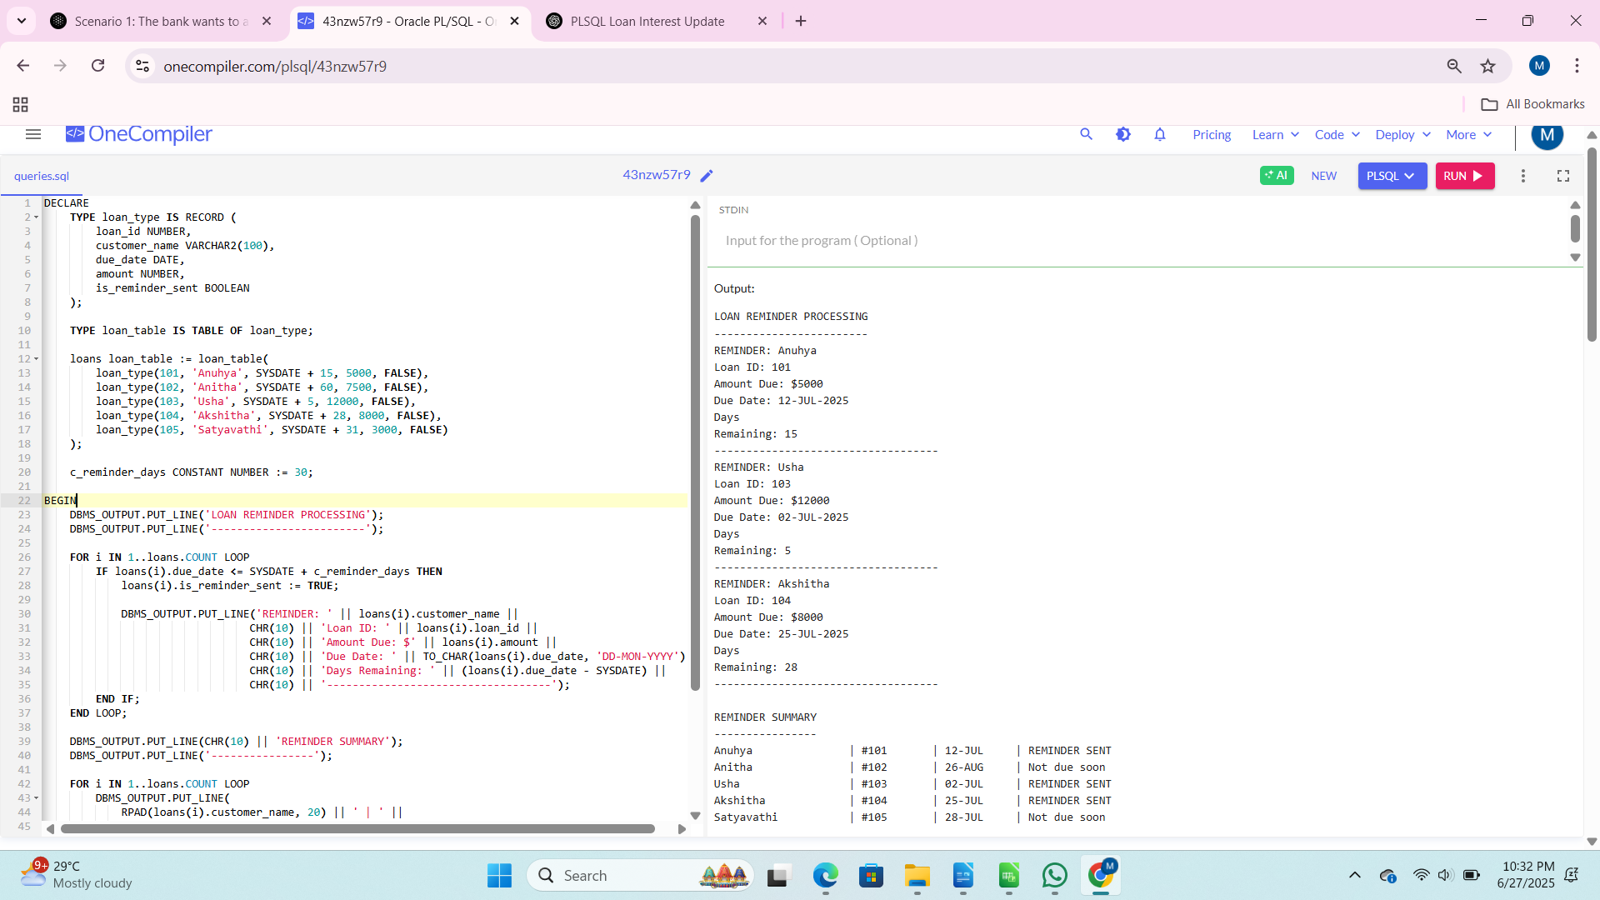
Exercise 3: Stored Procedures

Scenario 1: The bank needs to process monthly interest for all savings accounts.

Query:
DECLARE
TYPE AccountRecord IS RECORD (
account_id NUMBER,
account_holder VARCHAR2(100),
balance NUMBER(10, 2),
last_interest_date DATE
);

TYPE AccountTable IS TABLE OF AccountRecord INDEX BY PLS_INTEGER;

accounts AccountTable;

PROCEDURE ProcessMonthlyInterest IS
v_interest_rate CONSTANT NUMBER := 0.01;
BEGIN
FOR i IN 1 .. accounts.COUNT LOOP
accounts(i).balance := accounts(i).balance * (1 + v_interest_rate);
accounts(i).last_interest_date := SYSDATE;
END LOOP;
DBMS_OUTPUT.PUT_LINE('Applied 1% interest to all savings accounts.');
END ProcessMonthlyInterest;

BEGIN
accounts(1) := AccountRecord(1, 'Siddhi, 5000.00, NULL);
accounts(2) := AccountRecord(2, 'Hema', 10000.00, NULL);
accounts(3) := AccountRecord(3, 'Pavan', 7500.00, NULL);

DBMS_OUTPUT.PUT_LINE('=== Initial Balances ===');
FOR i IN 1 .. accounts.COUNT LOOP
DBMS_OUTPUT.PUT_LINE(
RPAD(accounts(i).account_holder, 15) || ': $' ||
TO_CHAR(accounts(i).balance, '999,990.00')
);
END LOOP;

ProcessMonthlyInterest();

DBMS_OUTPUT.PUT_LINE('=== Balances After Interest ===');
FOR i IN 1 .. accounts.COUNT LOOP
DBMS_OUTPUT.PUT_LINE(
RPAD(accounts(i).account_holder, 15) || ': $' ||
TO_CHAR(accounts(i).balance, '999,990.00')
);
END LOOP;
END;
/
Output:
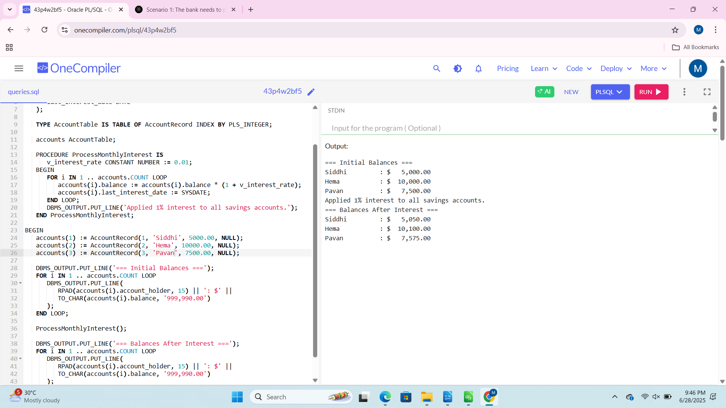
Scenario 2: The bank wants to implement a bonus scheme for employees based on their performance.

Query:

DECLARE
TYPE EmployeeRecord IS RECORD (
employee_id NUMBER,
employee_name VARCHAR2(100),
department VARCHAR2(50),
salary NUMBER(10, 2),
bonus_percentage NUMBER(5, 2),
updated_salary NUMBER(10, 2)
);

TYPE EmployeeTable IS TABLE OF EmployeeRecord INDEX BY PLS_INTEGER;
employees EmployeeTable;

PROCEDURE UpdateEmployeeBonus(
p_dept VARCHAR2,
p_bonus_percent NUMBER
) IS
BEGIN
DBMS_OUTPUT.PUT_LINE('Applying ' || p_bonus_percent || '% bonus to ' || p_dept || ' department');

FOR i IN 1..employees.COUNT LOOP
IF employees(i).department = p_dept THEN
employees(i).bonus_percentage := p_bonus_percent;
employees(i).updated_salary := employees(i).salary * (1 + p_bonus_percent/100);
DBMS_OUTPUT.PUT_LINE(' - ' || employees(i).employee_name ||
': ' || employees(i).salary || ' → ' ||
employees(i).updated_salary);
END IF;
END LOOP;
END UpdateEmployeeBonus;

BEGIN
employees(1) := EmployeeRecord(101, 'Mohini', 'Sales', 50000, 0, 50000);
employees(2) := EmployeeRecord(102, 'Sanvi', 'Sales', 55000, 0, 55000);
employees(3) := EmployeeRecord(103, 'Siddhi', 'IT', 60000, 0, 60000);
employees(4) := EmployeeRecord(104, 'Varun', 'HR', 45000, 0, 45000);
employees(5) := EmployeeRecord(105, 'Dolly', 'IT', 65000, 0, 65000);

DBMS_OUTPUT.PUT_LINE('=== Initial Salaries ===');
FOR i IN 1..employees.COUNT LOOP
DBMS_OUTPUT.PUT_LINE(
RPAD(employees(i).employee_name, 15) ||
RPAD(' (' || employees(i).department || ')', 10) ||
': $' || TO_CHAR(employees(i).salary, '999,990.00')
);
END LOOP;

UpdateEmployeeBonus('Sales', 10);

UpdateEmployeeBonus('IT', 5);

DBMS_OUTPUT.PUT_LINE('=== Updated Salaries ===');
FOR i IN 1..employees.COUNT LOOP
DBMS_OUTPUT.PUT_LINE(
RPAD(employees(i).employee_name, 15) ||
RPAD(' (' || employees(i).department || ')', 10) ||
': $' || TO_CHAR(employees(i).updated_salary, '999,990.00')
);
END LOOP;
END;
/
Output:

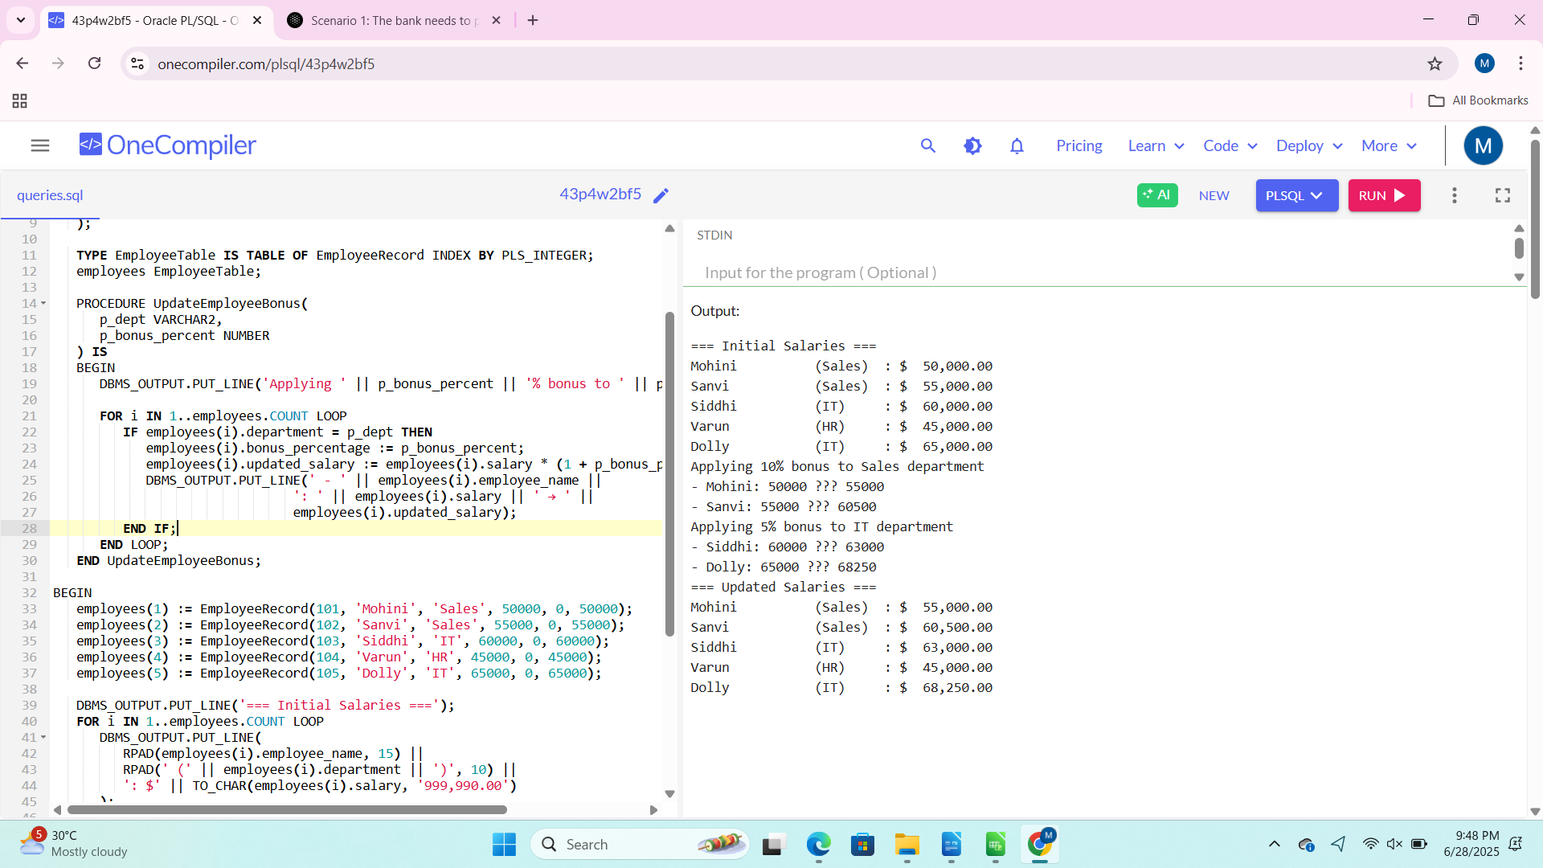
Scenario 3: Customers should be able to transfer funds between their accounts.

Query:

DECLARE
TYPE AccountRecord IS RECORD (
account_id NUMBER,
account_holder VARCHAR2(100),
balance NUMBER(10, 2)
);

TYPE AccountTable IS TABLE OF AccountRecord INDEX BY PLS_INTEGER;

accounts AccountTable;

PROCEDURE TransferFunds(
p_from_account_id NUMBER,
p_to_account_id NUMBER,
p_amount NUMBER
) IS
v_from_balance NUMBER;
v_to_balance NUMBER;
v_from_account_found BOOLEAN := FALSE;
v_to_account_found BOOLEAN := FALSE;
BEGIN
FOR i IN 1 .. accounts.COUNT LOOP
IF accounts(i).account_id = p_from_account_id THEN
v_from_balance := accounts(i).balance;
v_from_account_found := TRUE;
ELSIF accounts(i).account_id = p_to_account_id THEN
v_to_balance := accounts(i).balance;
v_to_account_found := TRUE;
END IF;
END LOOP;

IF NOT v_from_account_found THEN
DBMS_OUTPUT.PUT_LINE('Error: Source account not found.');
RETURN;
ELSIF NOT v_to_account_found THEN
DBMS_OUTPUT.PUT_LINE('Error: Destination account not found.');
RETURN;
END IF;

IF v_from_balance < p_amount THEN
DBMS_OUTPUT.PUT_LINE('Error: Insufficient balance in source account.');
RETURN;
END IF;

FOR i IN 1 .. accounts.COUNT LOOP
IF accounts(i).account_id = p_from_account_id THEN
accounts(i).balance := accounts(i).balance - p_amount;
ELSIF accounts(i).account_id = p_to_account_id THEN
accounts(i).balance := accounts(i).balance + p_amount;
END IF;
END LOOP;

DBMS_OUTPUT.PUT_LINE('Transfer successful: $' || p_amount ||
' transferred from account ' || p_from_account_id ||
' to account ' || p_to_account_id);
END TransferFunds;

BEGIN
accounts(1) := AccountRecord(101, 'Siddhi', 5000.00);
accounts(2) := AccountRecord(102, 'Mohith', 10000.00);
accounts(3) := AccountRecord(103, 'Pavan', 7500.00);

DBMS_OUTPUT.PUT_LINE('=== Initial Balances ===');
FOR i IN 1 .. accounts.COUNT LOOP
DBMS_OUTPUT.PUT_LINE(
'Account ID: ' || accounts(i).account_id ||
', Holder: ' || accounts(i).account_holder ||
', Balance: $' || TO_CHAR(accounts(i).balance, '999,990.00')
);
END LOOP;

TransferFunds(101, 102, 1500);
TransferFunds(102, 103, 2000);
TransferFunds(101, 103, 6000);

DBMS_OUTPUT.PUT_LINE('=== Updated Balances ===');
FOR i IN 1 .. accounts.COUNT LOOP
DBMS_OUTPUT.PUT_LINE(
'Account ID: ' || accounts(i).account_id ||
', Holder: ' || accounts(i).account_holder ||
', Balance: $' || TO_CHAR(accounts(i).balance, '999,990.00')
);
END LOOP;
END;
/

Output:

